Table of Contents
1. Updating From Legacy to Modern Configuration 2
1.1 Grant Permissions on Vault Application in Entra Admin Center 2
1.2 Update SharePoint Site with PowerShell 2
1.3 Authorize Connection between Vault and Office 365 3
2. Powershell Script Variables 4

Updating From Legacy to Modern Configuration

Grant Permissions on Vault Application in Entra Admin Center
Step | Completed | Comments
Navigate to Vault Admin > Settings > Checkout Settings and click Edit
In a separate window, login as Admin to Entra Admin Center
Click on App Registrations
Navigate to the existing App Registration setup for your Vault
From the Azure app page, click API permissions
Click Add a permission
Click Microsoft Graph and then Application Permissions
Under Sites section, check off:
- Sites.Selected
Under Users section, check off:
- User.ReadBasic.All*
Under Users section, check off:
- User.Invite.All **
Under Directory section, check off:
- Directory.ReadWrite.All **

*This permission is required if using collaborative authoring workflow actions.
**These permissions are for the optional Auto Invite External Users feature
Click Add permissions
Click Grant admin consent for <Tenant Name>
On the Entra ID application page, click Certificates & Secrets.
Create a new client secret if there is no existing Client Secret value or the existing Client Secret value expired, and it is important to record the Value to use later in the configuration process. |  | Client Secret Value  _________________

Update SharePoint Site with PowerShell
Step | Completed | Comments
Login to SharePoint Admin as the administrator user who will be running the PowerShell script
Navigate to the site to be updated
Add the SharePoint Admin account that will be running the script as an Owner on the site
Install PowerShell 7 (at least version 7)
Open PowerShell 7 and install PnP PowerShell Module with the following command:

Install-Module PnP.PowerShell -RequiredVersion 2.12
Download and edit the PowerShell scripts provided in Vault Help
Prepare the variables in the ‘SitePnP_UpdateExistingSite.ps1’ script. Each variable must be in a quote. Example: $adminUrl = "Admin URL"

$adminUrl = “The URL of the SharePoint Admin Center”
$tenantUrl = “The tenant domain name used for Azure app registrations”
$appId = “The App ID of the Entra App”
$displayName = “The name of the Entra App created in”
$siteUrl = “The full URL of the existing SharePoint site used for Collaborative Authoring”
$entraIDApp = “ID of the Azure Admin App that grants Collaborative Authoring Azure App access to the SharePoint site. If left blank, it will be dynamically created upon running this script”.
$adminAppName = "Veeva CA Admin App"

Important: See Powershell Script Variables for more information on how to set and use these variables.
Go the folder where you saved the PowerShell script.
Run the ‘SitePnP_UpdateExistingSite.ps1’ script in PowerShell command prompt as follows. If you have updated the name and the new name includes spaces or special characters, it is recommended to specify the entire file name within double quotes to avoid any issues with spaces & characters in the file name.

.\SitePnP_UpdateExistingSite.ps1

Authorize Connection between Vault and Office 365
Step | Completed | Comments
Check the Remove Service Account from Collaborative Authoring Configuration checkbox
Re-enter the Secret Value for the app’s Client Secret
Within Vault Checkout Settings, click Authorize
Once your Integration Status is verified within Vault Checkout Settings, click Save

Powershell Script Variables
$adminUrl = "https://test-admin.sharepoint.com"
You can get this URL by navigating to your SharePoint Admin center, and copying the first part of the URL there:
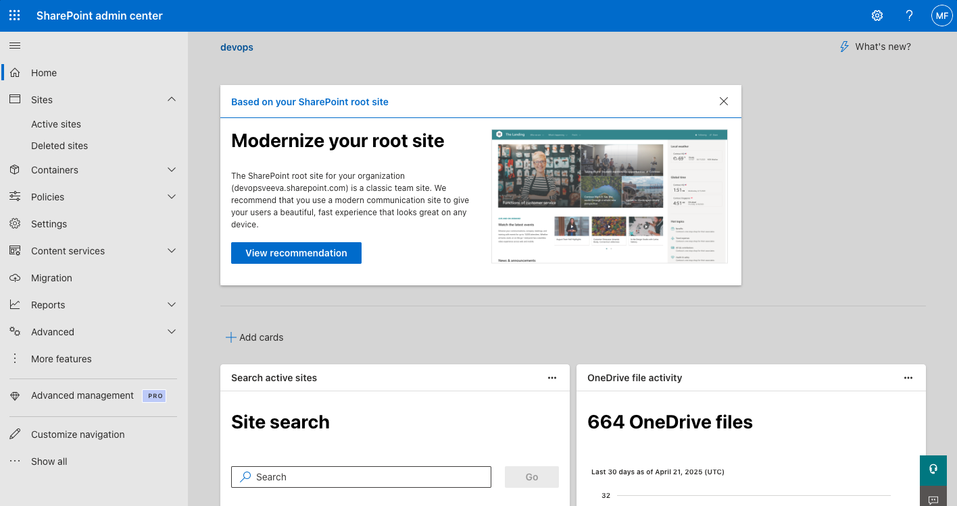
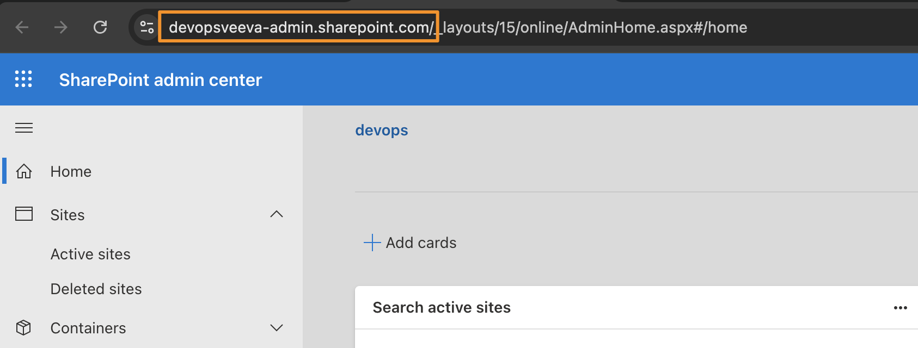
$tenantUrl = "domain.com"
You can get this URL by navigating to the Microsoft Entra Admin Center, and the Overview tab. The URL needed is the Primary Domain field:
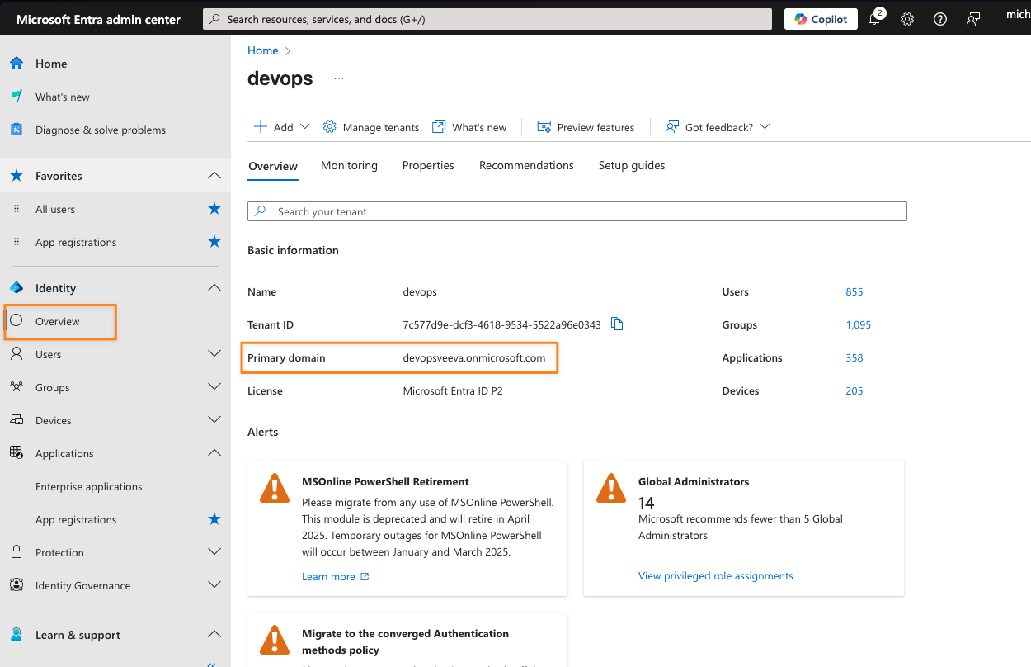

$appId = "appId"
This is the Application (client) ID for the app registration for your Vaults:
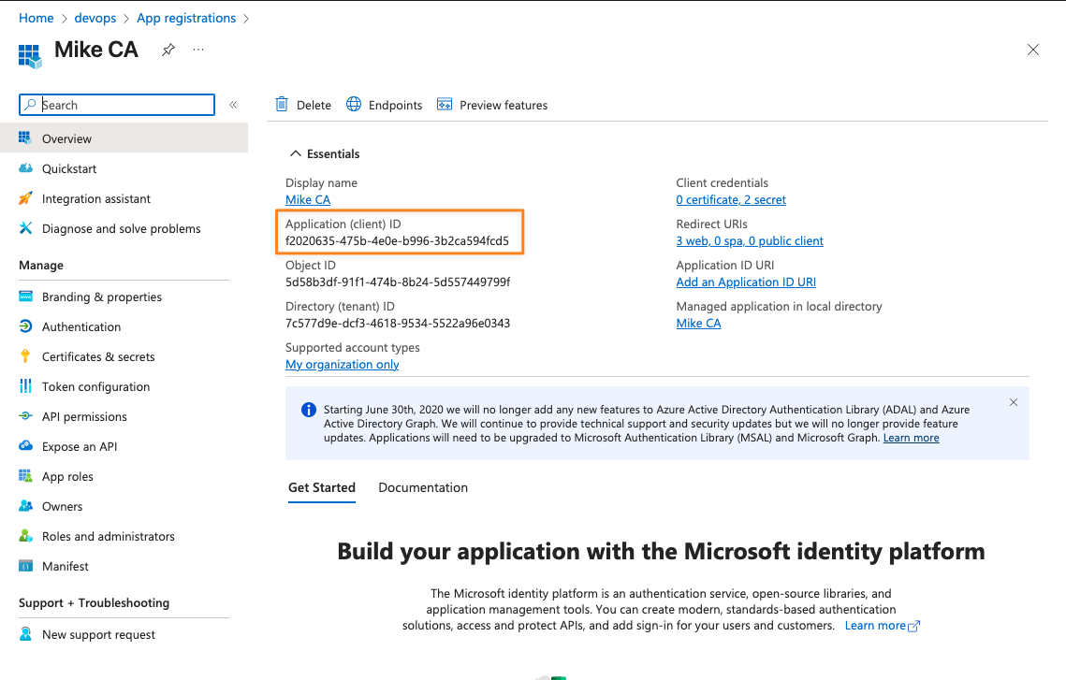

$displayName = "Display Name"
This is the Display Name for the app registration for your Vaults:
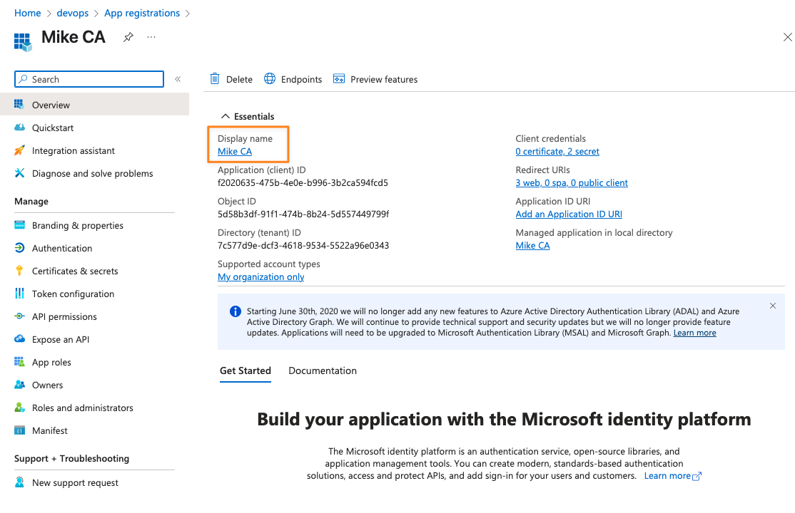

$siteUrl = “https://test.sharepoint.com/sites/siteAlias”
This is the URL for your existing SharePoint site, which you can get by navigating to the site in the SharePoint Admin center and copying the Site Address:
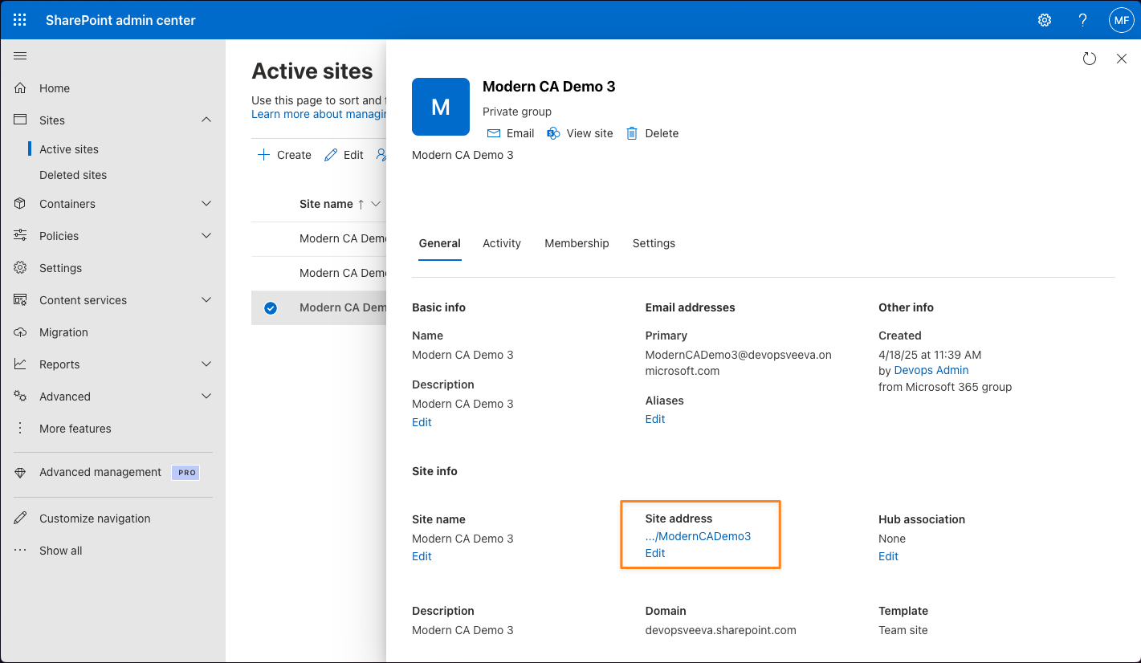

$adminAppName = "Admin App Name"
The script will create a Entra Admin ID App with the name you specify in this variable. This new app will get ‘AllSites.FullControl’ permission, and you can give this app any name that you prefer. This site permission is needed to grant your existing application permission to manage your SharePoint site (without a Service Account).
The first time you run the script, this variable should be used and the $entraIDApp variable should be commented out. For subsequent uses of the script, the newly created Entra Admin ID app can be used to configure Collaborative Authoring in other Vault environments in your organization. Record the app Id for future use and comment this variable out if you are planning to run this script again for other Vault environments.
This admin app is required to update permissions, but once all updates are made to existing app registrations and SharePoint sites, this app can be deleted.
$entraIDApp = "entraIdApp"
If you already have an Entra Admin app created using the above variable $adminAppName (that has the AllSites.FullControl permission), then comment out the variable $adminAppName and enter the Application (client) ID for that Entra Admin ID app here, rather than using $adminAppName to create a new Entra Admin App again.

